Virtual Lab 3 – Waveguide

# Youssef Samwel

# [yo800238@ucf.edu](mailto:yo800238@ucf.edu)

# EEL4436C Microwave Engineering

Section 0012

# Due Date 10/8/2023

**Rectangular Waveguide**

1. (10 pts) Plot the E field magnitude on the top surface of the waveguide for 6, 10, and 15 GHz. From the field plot, determine whether it is a propagating mode or evanescent mode at each frequency.
2. (10 pts) Calculate the guided wavelength *λg* at 10 GHz using the equation in the book and compare with the guided wavelength read from the field plots.
3. (10 pts) Calculate how many modes can exist at 18 GHz and identify the name of each mode.
4. (10 pts) Plot the vector E and H fields of each mode and provide the name of the mode in the plot.
5. (10 pts) Plot the vector electric current on the top surface and one side wall for TE10 mode at 10 GHz. What is the relationship between the current and the magnetic field for this mode? If you want to plot the fields for the higher-order mode, go to “HFSS”🡪 “Fields”🡪 “Edit Sources” and change the amplitude of the higher-order mode to be 1 and set the amplitude of other modes to be 0.

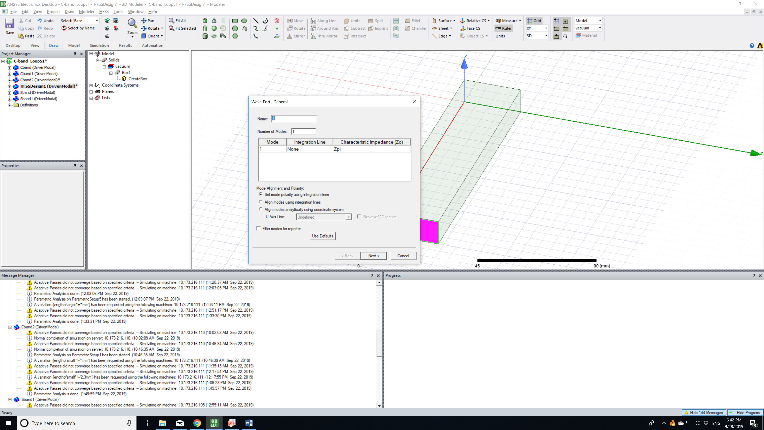

1. (10 pts) There is no unique definition of impedance for a waveguide which does not support TEM mode. To figure out which impedance is used in HFSS simulation, first read the port 1 impedance at 8, 10 and 12 GHz and then identify the formula for the impedance calculations in HFSS.

**Coaxial Line:**

1. (10 pts) What is the cutoff frequency of the first higher-order mode? Which mode is it?
2. (10 pts) Plot the vector E and H field distribution of the TEM and the first higher order mode.

**Circular Waveguide**

1. (10 pts) What is the cutoff frequency of the lowest and 1st higher-order modes? Which modes are they?
2. (10 pts) Plot the vector E and H field distribution of the two modes.